**APPLICATION DEVELOPMENT FOR FINDING FLATMATES**

**PRICING AND STRATEGY (SUBSCRIPTION)**

**If we look into the flatmate industry the potential customers are young male and female working professionals in the urban sector between the age group of 23-35 living in Tier 1/Tier 2 cities. Most of the customers are Smartphone users with an Internet connection. They prefer living in shared accommodation to reduce the cost of living and avoid boredom.**

**Objective:**

**To understand the user needs and demands for a flat-mate application service**

**Hypothesis:**

**●Primary: Most young working professionals in the age group 25 - 35 years and working in tier 1 cities would prefer living in shared accommodation to reduce financial stress.**

**●Secondary: People looking to stay in shared accommodation would not mind staying with strangers as their primary goal is cost reduction**

**Based on the Primary hypothesis it was found that most people moving between cities to work preferred staying in shared accommodation with the topmost reason being to reduce the cost of living.**

**Based on the Secondary hypothesis participants preferred staying with either friends or relatives.**

**●Majority of the population surveyed worked in Tier1 cities (90%) and were working professionals (84.1%)**

**●Max people belong to the Age group 23-32 (Approx. 75%)**

**●The population surveyed consists of 58.7% males and 41.3% females.**

**●About 68% of the population was unmarried.**

**●Maximum population preferred to stay in apartments (68.3%)**

**●Maximum population preferred to have individual/separate rooms in shared accommodation (74.6%)**

**●70% of the population is willing to pay up to 15k.**

**●62% preferred semi-furnished accommodations.**

**●The top amenities preferred were Lift, parking, nearby Public Transport, nearby grocery shop, and gas connection. (68%, 67%, 65%, 66% and 44% respectively)**

**●While the majority population stayed in tier 1 cities, they were originally from tier 2 and tier 3 cities (Like Nagpur, Haryana, Andhra Pradesh, Bihar, Pune, etc.). This means they have travelled from home towns to work in tier 1 cities.**

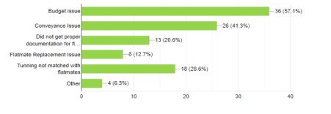

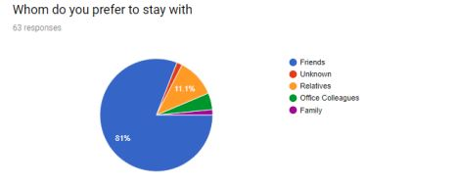

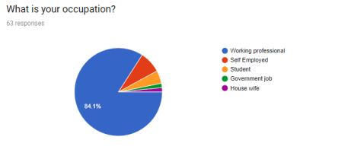

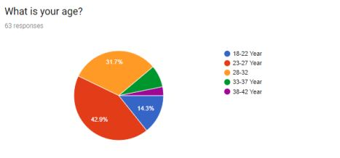

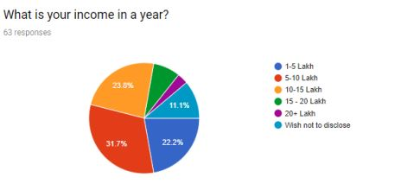

**So from the above highlighted points it can be concluded that pricing plays an important role in the flatmate industry. While some people are willing to live in apartments where the cost of living is low, some prefer to have apartments in areas where the standard of living is high and do not care much about the cost of living.**

**COMPETITIVE ANALYSIS:**

**1. FLATMATE.IN:**

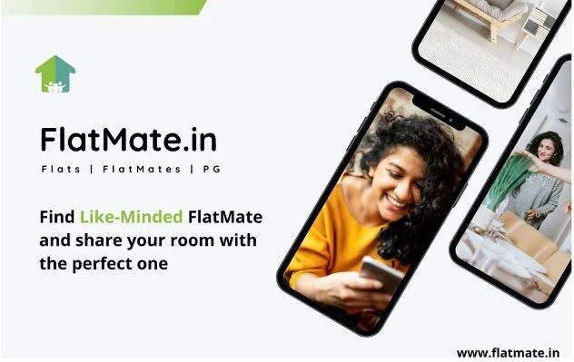

**With its premium subscription concept, FlatMate.in created the first social networking site for people to locate a roommate. In addition to sharing images and asking personal questions on their profile pages, members can match based on recommendations from friends. A messaging system allows users to effortlessly engage with other members, fostering a truly social environment.**

**For users who are unable to buy their premium plans, they have developed magnificent networks of Facebook groups with the names Flat and Flatmates for each major city. They provide services to at least 8–10 million users via their Facebook groups.**

**Subscription Fee and Automatic Renewal:**

**Flatmate subscription price is RS 499 per month. Your account will be charged at confirmation of your purchase and will automatically renew for the same price and duration period as the original package at the end of your current subscription period unless auto-renew is turned off at least 24 hour prior to the end of current period.**

**Rental Agreement:**

**The agreement is provided only as a general guidance and Flatmate does not take any responsibility for any loss or damage arising from the use of this template. User will not get notarized agreement copy (Soft Copy/Hard Copy) by Flatmate if needed he/she can notarize it from anywhere.**

**2. ROOMSTER:**



**Roomster is the world's largest online social network for roommates, With 4 million active listings we have what you are looking for. More people around the world are choosing to live together and we think sharing a place can be a brilliant living experience and a great way to save (or make) money.**

**Subscription Fees and Automatic Renewals:**

1. **Basic Membership: Becoming a member of the Service and creating a profile on the Service is free. This membership level constitutes “Basic Membership”. Basic Membership allows you to search, post and contact other members of the Service for free. Basic Membership provides you with access to potential roommates in each country where the Service is made available. With the Basic Membership, you can: bookmark members you like, receive daily matches via email, get matched with other members with our keyword and personality matching services, and send emails to other members of the Service to better introduce yourself.**
2. **Full Membership: You will also have the ability to upgrade your Basic Membership by subscribing to a “Full Membership”. If you sign up for a Full Membership subscription you will have access to all of the functionality provided as part of the Basic Membership plus access to a private mailbox on the Service, access to social connections which link directly to social network profiles added by other users of the Service, such as Facebook, LinkedIn, Twitter and Instagram, and access to the text/SMS or call options that will enable you to contact other users of the Service. Full Membership rates vary depending on the length of your initial subscription. You may purchase an initial Full Membership subscription from available packages. You will be asked to choose an initial Full Membership subscription period when you sign up for Full Membership.**
3. **Automatic Renewal: If you subscribe for Full Membership, your subscription will automatically renew at the end of applicable initial subscription period, unless you elect to cancel your subscription before the end of current subscription period. The cancellation will take effect after current subscription period ends, and your account will be downgraded to Basic Membership. If you do not cancel your subscription before the end of current subscription period, we will automatically charge your payment account following the end of the applicable initial subscription period.**

**3. SPAREROOM:**



**SpareRoom is a flat and house share site with over 9 million registered users.**

**Anyone can use SpareRoom completely free. If you're looking for a room and want to contact all adverts straight away, you can choose to upgrade to get early bird access. If you choose not to upgrade, you'll still be able to contact the blue bold adverts and ads over 7 days old. Early bird ads are free to contact after 7 days.**

**Free ads appear grey in the listings. Upgraded users will be able to contact you straight away - everyone else will be able to contact you once your ad is 7 days old.**

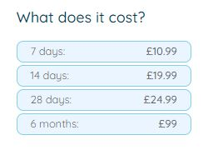

**BRANDING STRATEGY (USER & BRAND PERSONA)**

**What is brand strategy?**

**A brand strategy is the holistic approach behind how a brand builds identification and favourability with customers and potential customers. A brand strategy encompasses several different brand elements like voice, storytelling, brand identity, brand values, and overall vibe.**

**If your brand is how you present your business to the world, your branding strategy is the scaffolding that holds it up.**

**Why is developing a branding strategy important?**

**A strong brand is critical for building connections with customers. A successful brand strategy can help improve loyalty, drive brand awareness, build repeat business, and inspire word-of-mouth marketing and referrals.**

**Brands without effective brand strategies can become diluted, weak, or forgettable. Without a knockout product experience (and even with one) it’s easy for customers to move on rather than commit to a repeat purchase.**

**ANALYSIS:**

**Serviced apartments are in trend among guests for experiencing the comforts of a hotel without any hindrance to their privacy. With multiple properties present in the town, you need to level up your marketing game to be prominent among customers and**[**boost your service apartment’s profitability**](https://www.ezeeabsolute.com/blog/make-your-serviced-apartment-business-profitable/?utm_source=ServicedApartmentMarketing&utm_medium=blog&utm_campaign=eABlog)**.**

## What are the amenities and facilities in a serviced apartment?

**In any hospitality business, amenities and facilities are important USPs. Let’s take a look at some of them commonly found in serviced apartments:**

* **Spacious rooms**
* **Fully furnished kitchen**
* **Regular housekeeping**
* **Free Wi-Fi**
* **Access to the swimming pool in society**
* **24*7 security (CCTV, guards, app-based security system)**
* **Entertainment facilities (Smart TV,  society’s clubhouse, garden area)**
* **Centralized air conditioning**
* **Attractive interiors**
* **Power back-up**
* **Water purifier**

[**How to brand serviced apartments?**](https://www.ezeeabsolute.com/blog/serviced-apartment-marketing-strategies/#marketing)

* + [**Identify your guests**](https://www.ezeeabsolute.com/blog/serviced-apartment-marketing-strategies/#targetaudience)
  + [**List on online booking platforms**](https://www.ezeeabsolute.com/blog/serviced-apartment-marketing-strategies/#otas)
  + [**Invest in a website**](https://www.ezeeabsolute.com/blog/serviced-apartment-marketing-strategies/#website)
  + [**Promote your property with photography**](https://www.ezeeabsolute.com/blog/serviced-apartment-marketing-strategies/#photos)
  + [**Social media pages and groups can do wonders**](https://www.ezeeabsolute.com/blog/serviced-apartment-marketing-strategies/#socialmedia)
  + [**Highlight your locality and nearby facilities**](https://www.ezeeabsolute.com/blog/serviced-apartment-marketing-strategies/#locality)
  + [**Turn to WhatsApp messaging**](https://www.ezeeabsolute.com/blog/serviced-apartment-marketing-strategies/#whatsapp)
  + [**Partner with other businesses**](https://www.ezeeabsolute.com/blog/serviced-apartment-marketing-strategies/#partnership)

**USER PERSONA:**

**User personas are semi-fictitious representations of your target customers. A user persona is framed from real customer discovery and researching the needs, goals, and observed behavioural patterns of a target audience.**

**User personas help you get inside the mind of your audience. They allow you to gain valuable insights and make decisions based on your users’ needs**.

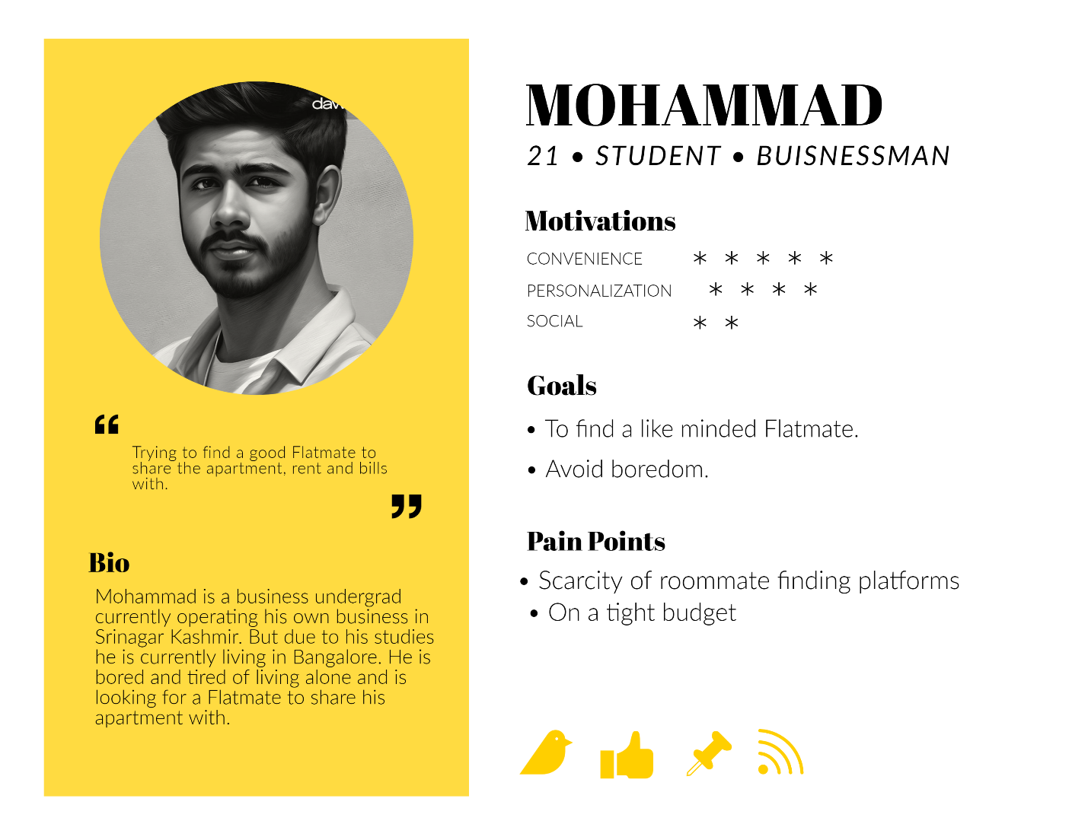

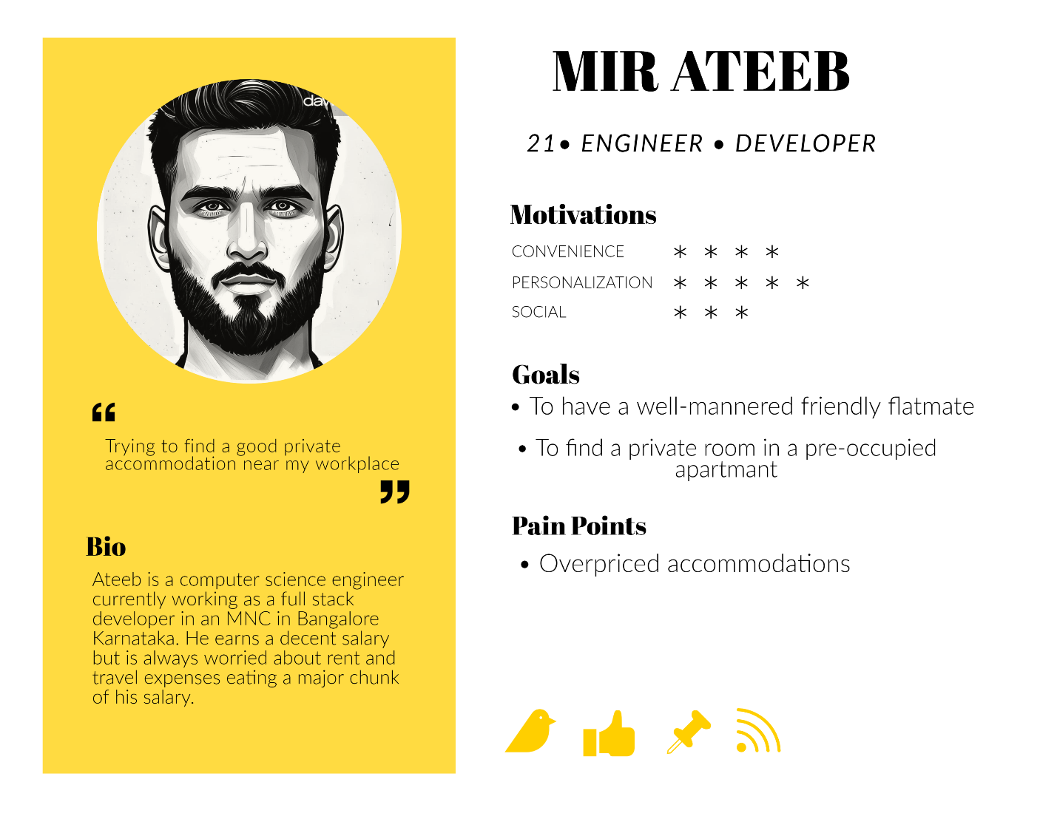

**BRAND PERSONA:**

**Brand persona and**[**buyer persona**](https://rockcontent.com/blog/buyer-persona/)**are two separate concepts in marketing, and both can help your company get better results when communicating with your audience.**

**But while a buyer persona relates to those your company wants to talk with, the brand persona indicates how you will be able to do so.**

**Confused?**

**A company needs to learn a lot of relevant topics about itself to hit the big leagues, and the brand persona is one of them.**

**Though we strive to build brand conversations that talk the language of our consumers, there’s a part of a brand that always shows off: the brand persona.**

**It involves the characteristics that stand out in your text, the message you’re aiming to deliver, and how all of this is received.**

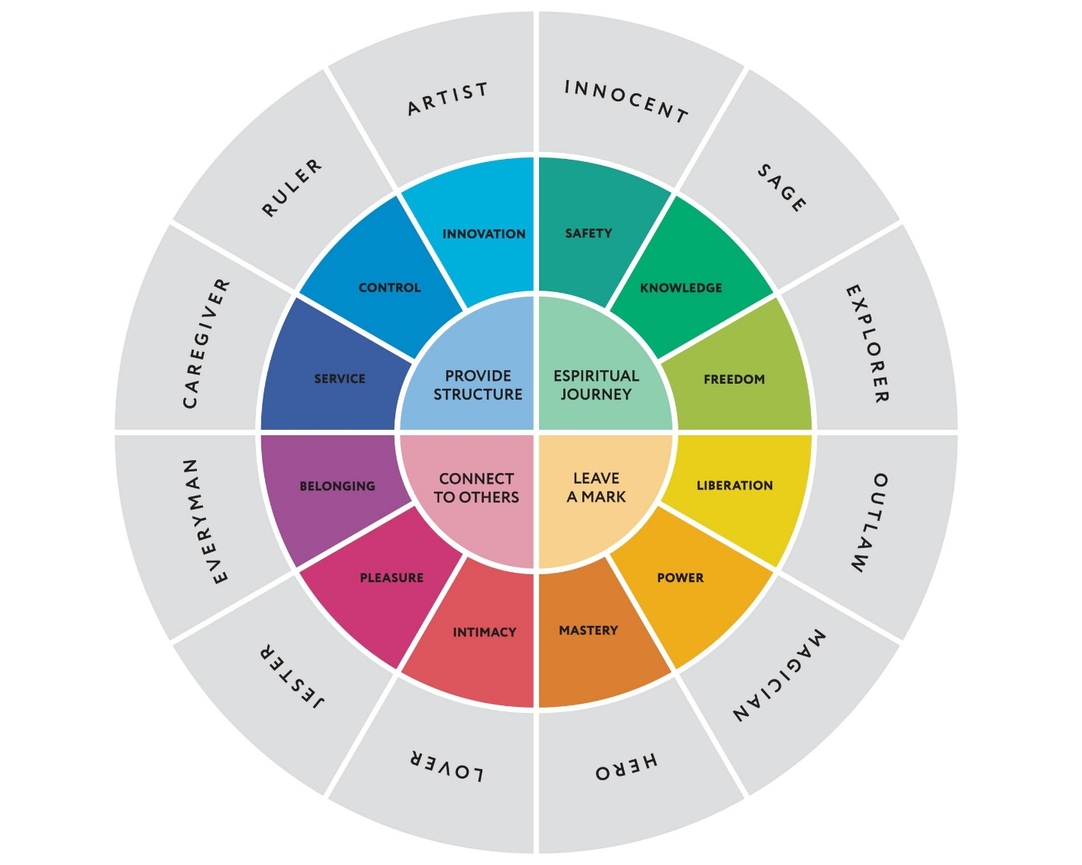

**5 KEY BRANDING PERSONAS**

**Historically, brand personas fit into several different “buckets" based on human behaviour. If you are new to personas, this is a good place to start.**

**Caregiver: This nurturing persona is empathetic and kind.**

**Competent: This persona is an influential leader that can help users or sway them to act.**

**Excited: This spirited persona is happy to do just about anything and embarks on adventures with ease.**

**Rugged: This more muscular persona is athletic and tough.**

**Sophisticated: This persona exudes elegance, style and prestige.**

**REPORT CREATED BY**

**FAHAD IQBAL SHAH**

**PRODUCT MANAGEMENT INTERN**

**NOVO CABS**